**Knee Osteoarthritis Classification using Federated Learning with FedAvg Approach**

**IMPLEMENTATION RESULTS**

1. **DenseNet169 - TensorFlow**

Global Model Accuracy: 83.79 %

Global Model Loss: 0.4182

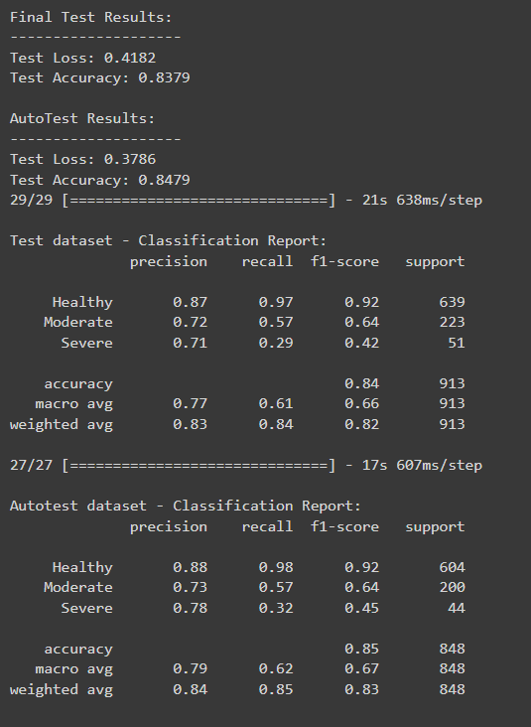

Round Accuracies and Losses:

|  |  |
| --- | --- |
| **Round** | **Global Accuracy** |
| 1 | 73.10 % |
| 2 | 78.95 % |
| 3 | 80.26 % |
| 4 | 82.86 % |
| 5 | 83.51 % |
| 6 | 83.51 % |
| 7 | 84.81 % |
| 8 | 83.51 % |
| 9 | 84.81 % |
| 10 | 83.94 % |
| 11 | 84.59 % |
| 12 | 85.68 % |

Test Dataset Confusion Matrix:

Auto-test Dataset Confusion Matrix:

1. **DenseNet201 Model – TensorFlow Framework:**

Global Model Accuracy: 83.79 %

Global Model Loss: 0.4182

Round Accuracies and Losses:

|  |  |
| --- | --- |
| **Round** | **Global Accuracy** |
| 1 | 73.10 % |
| 2 | 78.96 % |
| 3 | 80.26 % |
| 4 | 82.86 % |
| 5 | 83.51 % |
| 6 | 83.51 % |
| 7 | 84.82 % |
| 8 | 83.51 % |
| 9 | 84.82 % |
| 10 | 83.95 % |
| 11 | 84.60 % |
| 12 | 85.68 % |

Test Dataset Confusion Matrix:

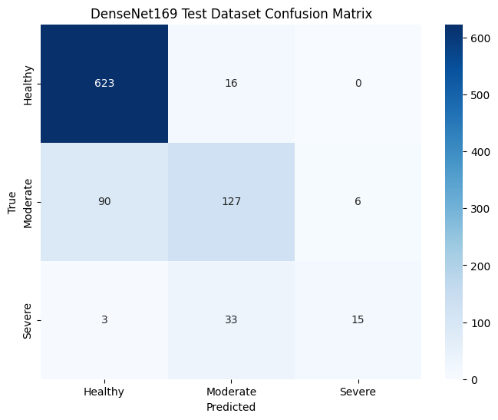

Auto-test Confusion Matrix:

1. **InceptionResNetV2 Model – TensorFlow Framework**

Global Model Accuracy: 79.41 %

Global Model Loss: 0.4760

Round Accuracies and Losses:

|  |  |
| --- | --- |
| **Round** | **Global Accuracy** |
| 1 | 73.97 % |
| 2 | 77.01 % |
| 3 | 76.79 % |
| 4 | 76.79 % |
| 5 | 79.18 % |
| 6 | 79.18 % |
| 7 | 79.39 % |
| 8 | 79.39 % |
| 9 | 80.91 % |
| 10 | 82.00 % |
| 11 | 81.13 % |
| 12 | 82.65 % |

Test Dataset Confusion Matrix:

Auto-Test Confusion Matrix:

1. **DenseNet201 Model – PyTorch Framework**

Global Model Accuracy: 95.18 %

Global Model Loss: 0.1455

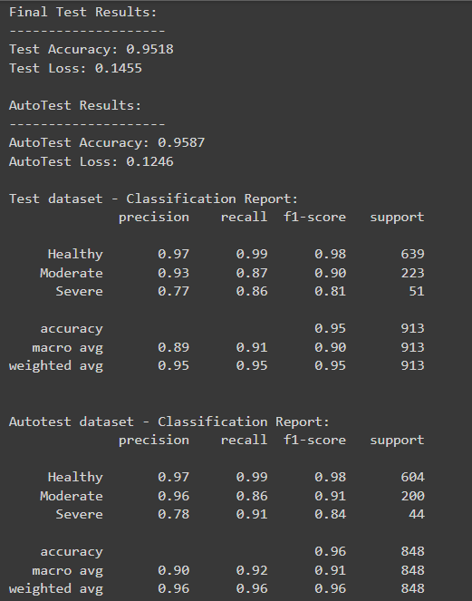

Round Accuracies and Losses:

|  |  |
| --- | --- |
| **Round** | **Global Accuracy** |
| 1 | 71.15 % |
| 2 | 84.38 % |
| 3 | 86.33 % |
| 4 | 86.12 % |
| 5 | 90.67 % |
| 6 | 90.46 % |
| 7 | 91.32 % |
| 8 | 92.62 % |
| 9 | 94.14 % |
| 10 | 93.71 % |
| 11 | 90.89 % |
| 12 | 93.28 % |

Test Dataset Confusion Matrix:

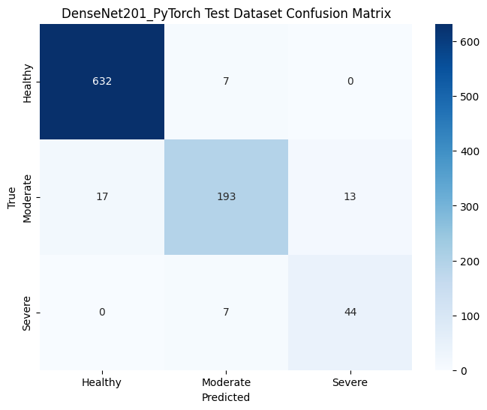

Auto-Test Confusion Matrix:

1. **InceptionResNetV2 Model – PyTorch Framework:**

Global Model Accuracy: 94.58 %

Global Model Loss: 0.1813

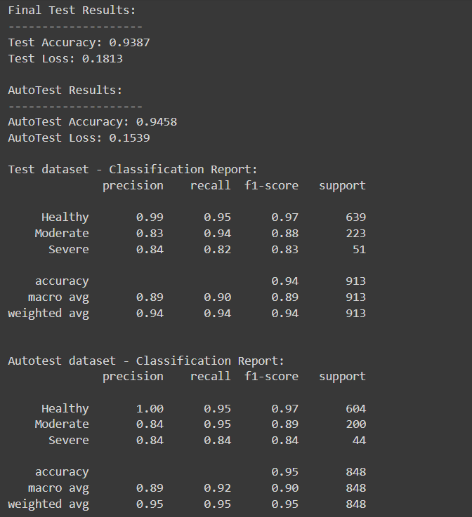

Round Accuracies and Losses:

|  |  |
| --- | --- |
| **Round** | **Global Accuracy** |
| 1 | 85.68 % |
| 2 | 88.07 % |
| 3 | 88.29 % |
| 4 | 91.32 % |
| 5 | 92.62 % |
| 6 | 93.49 % |
| 7 | 94.14 % |
| 8 | 93.93 % |
| 9 | 93.93 % |
| 10 | 94.14 % |
| 11 | 95.23 % |
| 12 | 91.11 % |

Test Dataset Confusion Matrix:

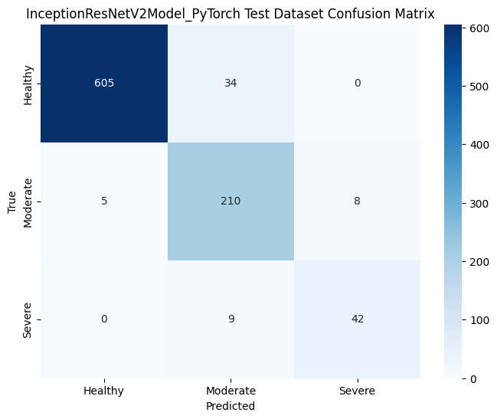

Auto-Test Dataset Matrix:

1. **DenseNet201 Model – PyTorch Framework – Weight Initialization**

Global Model Accuracy: 94.96%

Global Model Loss: 0.1460

Round Accuracies and Losses:

|  |  |
| --- | --- |
| **Round** | **Global Accuracy** |
| 1 | 71.15 % |
| 2 | 73.97 % |
| 3 | 81.13 % |
| 4 | 82.43 % |
| 5 | 86.99 % |
| 6 | 90.46 % |
| 7 | 86.77 % |
| 8 | 90.02 % |
| 9 | 91.32 % |
| 10 | 91.76 % |
| 11 | 91.76 % |
| 12 | 93.06 % |

Test Dataset Confusion Matrix:

Auto-Test Dataset Confusion Matrix:

1. **InceptionResNetV2 Model – PyTorch Framework – Weight Initialization**

Global Model Accuracy: 95.51%

Global Model Loss: 0.1483

Round Accuracies and Losses:

|  |  |
| --- | --- |
| **Round** | **Global Accuracy** |
| 1 | 48.81 % |
| 2 | 87.85 % |
| 3 | 91.54 % |
| 4 | 90.02 % |
| 5 | 92.19 % |
| 6 | 91.32 % |
| 7 | 92.62 % |
| 8 | 94.79 % |
| 9 | 94.36 % |
| 10 | 94.14 % |
| 11 | 94.14 % |
| 12 | 93.71 % |

Test Dataset Confusion Matrix:

Auto-Test Dataset Confusion Matrix:

